**Segundo Trabalho de Redes de Computadores**

**TELC-03/2018**

**Protocolo MQTT**

**I-INTRODUCAO**

* **MQTT : MQ -Telemetry Transport - Message Queue Telemetry Transport**
* It is a Lightweight messaging protocol designed for sensors and devices with:
* Flaky network connectivity
* Low computing power
* Connections where bandwidth is at a premium
* Protocol specification is open source
* MQTT is nearly 10 years old. Therefore is a mature and evolving protocol
* Publish and Subscribe to topics
* 3 qualities of service
* Best effort to deliver a message
* Deliver atleast once
* Deliver exactly once
* Supports Retained publications
* Minimal transport overhead to reduce network traffic
* As little as 2 bytes
* Last Will and Testament

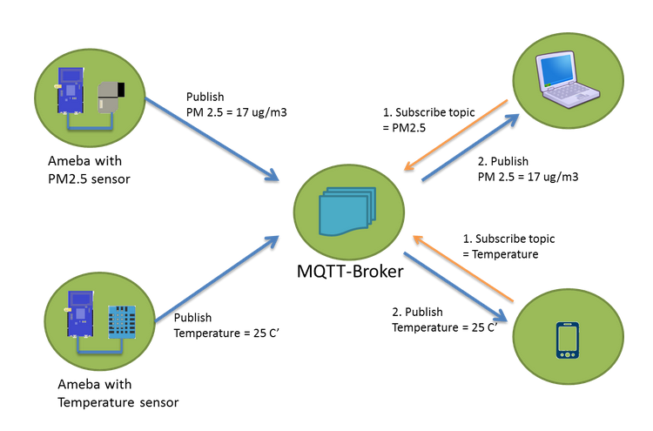

**Example: Home Pacemaker Monitoring Solution**

A compnay was asked to create a solution (illustrated in the next Figure) in which an MQTT client is embedded in a home monitoring appliance that collects diagnostics whenever the patient is in close proximity to a base unit. The base unit sends the diagnostic data over the Internet to the central messaging server, where it is handed off to an application that analyzes the readings and alerts the medical staff if there are signs the patient might be having difficulty. The solution allows the organization to provide a higher level of post-hospital patient care and early diagnosis of followup issues. It also saves money for both the organization and its patients, because there is less need for travel by either party and because patients who are doing well might be allowed to come in for checkups less often.

Characteristics:

* Sensors on Patient;
* Collected by a monitoring equipment in home (broker) using MQTT;
* Subscribed by a computer in the hospital;
* Alerts the doctor if anything is out-of-order;

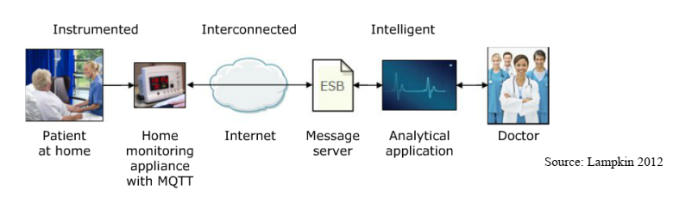

**II-TAREFA**

Voce deverá implemntar uma aplicacao qualquer usando o protocolo MQTT. Uma boa fonte de exemplos é o GitHub. Nele voce poderá encontrar diversas aplicacoes usando MQTT e entao adaptá-las para a plataforma no LAB LSE.

A aplicacao deverá seguir o modelo do exemplo abaixo (nao necessariamente com os mesmos dados para publish/subscribe.:

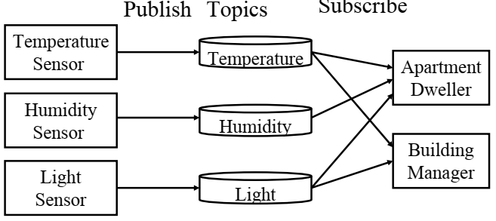

A demonstracao da aplicacao será no Lab LSE em horário a ser combinado com o professor.voce deverá fazer um relatorio explicando sua aplicacao e colocando o código fonte.

Data para entrega/demonstracao: 07/12/2018 no Horário de Aula de Lab.